Exercise 02 (22S) Companion File

# Simple UML Class Diagram for Class Cabbage

|  |
| --- |
| Cabbage |
| weight  costPerKilogram |
| calculatePrice()  printReport() |

* You will need to create a detailed UML Class Diagram for class Cabbage:
* A detailed UML Class diagram has access modifiers (public +, private -), data types, method return types, the get and set methods, and constructor(s).
* See the Week 3 lecture slide set for examples with class Apple, the detailed UML Class diagram examples are near the end of the slide set.

# Pseudocode for method main of class Exercise02

start

declarations

Cabbage cabbage

num weight // number containing decimal places

num cost // number containing decimal places

num price // number containing decimal places

output "Enter weight: "

input weight

output "Enter cost per kilogram: "

input cost

// test get-set methods by setting values first

cabbage.setWeight(weight)

cabbage.setCostPerKilogram(cost)

// test get-set methods by getting values back

// then check if the set value matches the value we got back from the get

weight = cabbage.getWeight()

costPerKilogram = cabbage.getCostPerKilogram()

// test the worker method

price = cabbage.calculatePrice()

// output results for visual verification

output "cabbage.getWeight() is: " + weight

output "cabbage.getCostPerKilogram() is: " + costPerKilogram

output "cabbage.calculatePrice() is: " + price

output "cabbage.printReport() is: "

cabbage.printReport()

output "Testing overloaded constuctor with anotherCabbage"

output "weight 3.5, cost per kilogram 2.50"

output "anotherCabbage.printReport() is: "

declarations

Cabbage anotherCabbage(3.5, 2.50) // no need for input, use literal values

anotherCabbage.printReport()

// output student name (as in ACSIS) for all homework.

output "program implemented by Student Name"

stop

(Flowchart is on next page)

# Flowchart for method main of class Exercise02

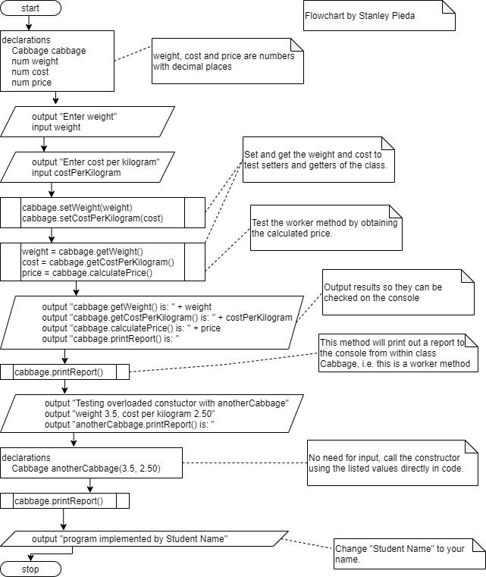

# Extra: Detailed UML Class Diagram Class Exercise02

|  |
| --- |
| Exercise02 |
|  |
| +main(args:String[]):void |

Note: Static methods are underlined in UML class diagrams.

Note: Your class Cabbage should have no static methods.